Chapter 14, Problem 66.

A ``general'' first-order filter is shown in Fig. 14.93.

(a) Show that the transfer function is

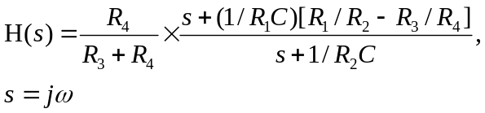

(b) What condition must be satisfied for the circuit to operate as a highpass filter?

(c) What condition must be satisfied for the circuit to operate as a lowpass filter?

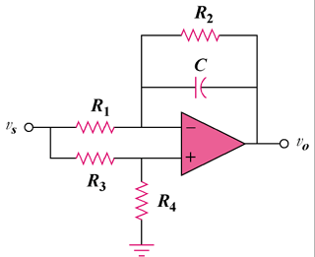

Figure 14.93
For Prob. 14.66.

